[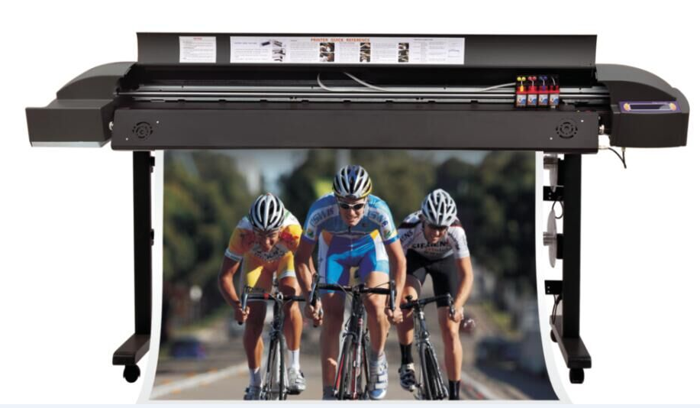](http://www.ldy114.com/en/productmore.php?id=635)

[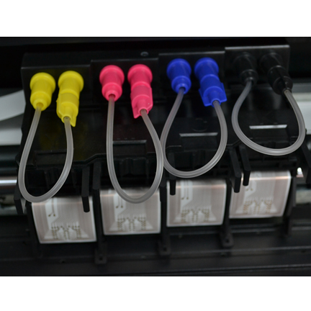](http://www.ldy114.com/en/productmore.php?id=635)

[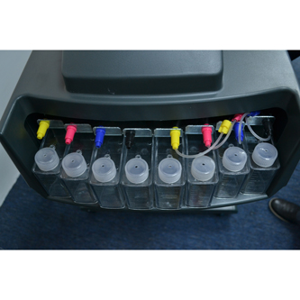](http://www.ldy114.com/en/productmore.php?id=635)

[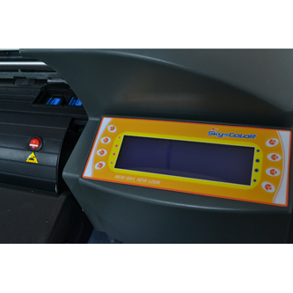](http://www.ldy114.com/en/productmore.php?id=635)

[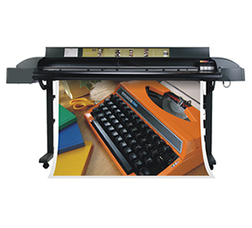](http://www.ldy114.com/en/productmore.php?id=635)

**Novajet 760 printer**

Model:SC-760 Specifications: 1.6m  
Volume：2500*550*400mm　Weight：100kg  
Description：  
Novajet 760 printer

Technology Hot hair bubble type  
Dry the system The heat dries the system, making appearance brighter NEW

|  |  |
| --- | --- |
| Model: | LD-760 |
| Ink Supply System: | The 500 ml continues to provide the ink system |
| Media Types | PP, Mutually paper |
| Resolution: | 600DPI |
| Print Speed | 2pass 9.0㎡/h 3pass 7.2㎡/h 4pass 5.3㎡/h 6pass 4.4㎡/h |
| Printing Width | 152cm |
| Light grid | HP-RTL HP/GL2 |
| Power: | 170-250V 50HZ |
| Consume Power | 20W, 185W, 285W |
| Operation Environment: | 5-35 C 10-70%RH |
| RIP Software: | The LB profession document prints the procedure |
| Language: | Chinese, English, French, German, Italian |

**Sky Color SC-760 Encad Novajet plotter printer**

* Product:

Almost New , Warranty from original seller, Old Invoice

* Item number:

114472176

* Availability:

**Unavailable**

* Price:

€ 995.00

* The ad expired on:

21.06.2012, 03:30

* Do you have a problem?

[Asks the seller](https://www.okazii.ro/imprimanta-sky-color-sc-760-plotter-encad-novajet-a114472176)

* Sold by:

[sanzy98](https://www.okazii.ro/comunitati/okazia-lui/sanzy98.html)

* You also sell:

Put a product like this [on sale](https://www.okazii.ro/vinde)

* Options:

[See similar products](https://www.okazii.ro/recomandate/imprimanta-sky-color-sc-760-plotter-encad-novajet-a114472176)